Implementation Document

for

Lostify

Version 1.0

Prepared by

|  |  |
| --- | --- |
| Group #6 | Group Name: hAPPy Developers |

|  |  |  |
| --- | --- | --- |
| Aayush Kumar | 230027 | [aayushk23@iitk.ac.in](mailto:aayushk23@iitk.ac.in) |
| Aman Raj | 230116 | [amanraj23@iitk.ac.in](mailto:amanraj23@iitk.ac.in) |
| Anirudh Cheriyachanaseri Bijay | 230140 | [anirudhcb23@iitk.ac.in](mailto:anirudhcb23@iitk.ac.in) |
| Ayush Patel | 220269 | [ayushpatel22@iitk.ac.in](mailto:ayushpatel22@iitk.ac.in) |
| Krishna Kumayu | 230576 | [kkrishna23@iitk.ac.in](mailto:kkrishna23@iitk.ac.in) |
| Marada Teja Satvik | 230636 | [maradateja23@iitk.ac.in](mailto:maradateja23@iitk.ac.in) |
| Satwik Raj Wadhwa | 230937 | [satwikraj23@iitk.ac.in](mailto:satwikraj23@iitk.ac.in) |
| Shaurya Johari | 230959 | [shauryaj23@iitk.ac.in](mailto:shauryaj23@iitk.ac.in) |
| Somaiya Narayan Aniruddh | 231019 | [snarayana23@iitk.ac.in](mailto:snarayana23@iitk.ac.in) |
| Vinay Chavan | 231155 | [vinay23@iitk.ac.in](mailto:vinay23@iitk.ac.in) |

|  |  |
| --- | --- |
| Course: | CS253 |
| Mentor TA: | Jeswaanth Gogula |
| Date: | 28 March 2025 |

Contents

Contents ii

Revisions iii

1 Implementation Details 1

1.1 Frontend 1

1.2 Backend 2

1.3 Database 10

1.4 External Services 11

1.5 Build System 11

2 Codebase 12

2.1 Repository 12

2.2 Codebase Navigation 12

3 Completeness 19

3.1 Implemented Features 19

3.2 Future Development Plans 21

Appendix A – Group Log 23

Revisions

|  |  |  |  |
| --- | --- | --- | --- |
| **Version** | **Primary Author(s)** | **Description of Version** | **Date Completed** |
| 1.0 | Aayush Kumar  Aman Raj  Anirudh Cheriyachanaseri Bijay  Ayush Patel  Krishna Kumayu  Marada Teja Satvik  Satwik Raj Wadhwa  Shaurya Johari  Somaiya Narayan Aniruddh  Vinay Chavan | Preliminary draft | 28/03/25 |

# Implementation Details

## Frontend

### Programming Language

The frontend is written in Dart, an object-oriented, garbage-collected language inspired by C++, Java, and JavaScript among others. The choice for Dart is influenced by its close integration with the Flutter framework as well as ease of coding, its closeness to mainstream OOP languages, built-in null safety and memory safety, runtime type identification, and the availability of native debugging and performance tools (Dart DevTools).

### Framework

The frontend uses the Flutter framework, which greatly simplifies app development with its fast performance and easy-to-understand hierarchy based on OOP principles. Key features include:

* **Widgets:** Flutter considers all UI elements widgets. This allows for uniformity amongst UI elements and a tree-style class hierarchy.
* **Stateful hot reload:** This revolutionary feature alleviates the need for compiling the source code from scratch to test any change in the code, a rather time-consuming process. Changes to UI elements do not change program state. For significant changes, a **stateful hot restart** can be performed.
* **Expressive UI:** Flutter provides a rich set of widgets and colour palettes conforming to the Material Design 3.0 specification with easy customization to suit the app theme, resulting in a beautiful yet familiar UI and an intuitive user experience.
* **Performance:** Flutter provides just-in-time (JIT) and ahead-of-time (AOT) compilation to enhance performance of applications.
* **Portability:** Dart code can, by itself, be compiled to native machine code, JavaScript, or WebAssembly. With the Flutter framework, Dart code can additionally be compiled to suit Android and iOS devices. Moreover, the user interface remains the same across various devices, screen sizes, and operating systems for the same class of devices.

### Packages and Libraries

Flutter uses Dart’s [*pub.dev*](https://pub.dev/) package manager and software repository to extend functionality.

* **flutter:** Defines widgets corresponding to UI elements and colour palettes as described in the Material Design 3.0 specification.
* **cloud_firestore:** Handles cloud storage hosted by Firebase, exposing an API to read, write, and update documents stored.
* **firebase_messaging:** Manages real-time messaging between users supported by Firebase’s Cloud Firestore service.
* **one_signal:** Provides real-time push notification service for mobile apps, integrating with the chat system.
* **http:** Sets up an HTTP client to connect and communicate with the backend using the request-response pattern.
* **provider:** Aids in state management, allowing efficient and scalable management of application state. It helps in maintaining separation between UI and business logic.
* **image_picker:**  Used to select images from the device’s gallery or capture photos using the camera, making it easy to handle media input in the application.

## Backend

### Programming Language

The backend is written in Python, a popular language for scripting and rapid development. With its rich set of libraries and built-in modules, duck typing paradigm, intuitive syntax that approaches natural language constructs, portability, and highly performant exception handling, Python has huge appeal for backend development.

### Framework

The backend utilises the Flask framework written in Python, which eases backend development with several out-of-the-box features and libraries that abstract away most of the implementation detail while ensuring security and best practices. Some features that stand out are:

* **Simplicity and code readability:** Flask, being written in Python, inherits all its merits with regard to developer experience.
* **Security:** Flask defaults to secure, signed session cookies and comes packaged with the Werkzeug library, which implements cryptographically secure algorithms for secure authentication and storage of credentials such as salting and hashing of passwords.
* **Blueprints:** Flask provides code modularity through the concept of blueprints. Blueprints group routes related to each other (such as steps constituting an action or methods to access and modify a resource) together.
* **Inbuilt support for URL routing:** Flask handles URL routing through function decorators, mitigating boilerplate to call route-related functions and to parse parameters embedded in the URL path.

### Packages and Libraries

Libraries included with Flask are combined with the Python Standard Library and external libraries handled through [pip](https://pypi.org/project/pip/), Python’s package manager.

* **flask:** Defines widgets corresponding to UI elements and colour palettes as described in the Material Design 3.0 specification.
* **werkzeug:** Implements the WSGI interface in full conformance with the Python specification. The werkzeug.security module provides security-related features in adherence to cryptographic standards.
* **python_dotenv:** Manages environment variables defining paths to configuration files and local storage and API keys for cookie signing and external API authentication.
* **azure.communication.email:** Provides a Python interface to Microsoft Azure Email Communication Services to mail OTPs to users.
* **sqlite3:** Exposes the SQLite3 API through a Python interface to handle SQLite3 databases. Conforms to the Python Database API Specification v2.0.
* **secrets:** Includes the SystemRandom class, which generates random numbers using the highest-quality sources provided by the operating system. This is used for OTP generation.

### API Endpoints

The backend exposes a RESTful API that the frontend communicates with using the HTTP protocol. This design enables a complete rewrite of the frontend without affecting the backend; similarly, backend logic can be altered without affecting the frontend. The implementation of each is opaque to the other.

The API exposes the following endpoints accessible through the specified URLs and HTTP methods:

#### Authentication

|  |  |
| --- | --- |
| **URL** | /auth/signup/get_otp |
| **Method** | POST |
| **Purpose** | Initiate a registration request and send an OTP. |
| **Request Data** | MIME type: application/json  {  username,  password,  profile } |
| **Response Status** | Success:   * **201:** OTP sent   Failure:   * **400:** Type mismatch for JSON field(s) * **400:** Username must be alphanumeric * **400:** Field is required * **405:** Method not allowed * **409:** User already exists |

|  |  |
| --- | --- |
| **URL** | /auth/signup/verify_otp |
| **Method** | POST |
| **Purpose** | Complete a registration request by verifying the OTP supplied by the user. |
| **Request Data** | MIME type: application/json  {  username,  otp } |
| **Response Status** | Success:   * **201:** User created   Failure:   * **400:** Type mismatch for JSON field(s) * **400:** Username is required * **401:** Incorrect OTP * **404:** Username not found * **404:** OTP timed out * **405:** Method not allowed |

|  |  |
| --- | --- |
| **URL** | /auth/login |
| **Method** | POST |
| **Purpose** | Authenticate a user and set session cookies upon successful verification of credentials. |
| **Request Data** | MIME type: application/json  {  username,  password } |
| **Response Status** | Success:   * **200:** User authenticated   Failure:   * **400:** Field is required * **401:** Incorrect password * **404:** Username not found * **405:** Method not allowed * **429:** Login attempt limit reached |

|  |  |
| --- | --- |
| **URL** | /auth/logout |
| **Method** | GET, HEAD |
| **Purpose** | Clear session cookies. |
| **Request Data** | None. |
| **Response Status** | Success:   * **205:** Successful logout; reset content |

|  |  |
| --- | --- |
| **URL** | /auth/change_password |
| **Method** | POST |
| **Purpose** | Change the account password. |
| **Request Data** | MIME type: application/json  {  old_password,  new_password  } |
| **Response Status** | Success:   * **204:** Password changed   Failure:   * **400:** Old/New password is required * **401:** User not logged in * **401:** Incorrect password * **404:** Username not found * **405:** Method not allowed |

|  |  |
| --- | --- |
| **URL** | /auth/reset_password |
| **Method** | POST |
| **Purpose** | Reset the account password if forgotten. |
| **Request Data** | MIME type: application/json  {  username } |
| **Response Status** | Success:   * **204:** New password sent to email   Failure:   * **404:** User not found * **405:** Method not allowed |

#### Post Handling

|  |  |
| --- | --- |
| **URL** | /items/post |
| **Method** | POST |
| **Purpose** | Create a new post. |
| **Request Data** | MIME type: application/json  {  type,  title,  description,  location1,  location2,  image } |
| **Response Status** | Success:   * **201:** Post created successfully   Failure:   * **400:** Field is required * **400:** Type must be either 0 or 1 * **401:** User not logged in * **405:** Method not allowed |

|  |  |
| --- | --- |
| **URL** | /items/<int:id> |
| **Method** | GET |
| **Purpose** | Retrieve details of the post with post id id. |
| **Request Data** | None. |
| **Response Status** | Success:   * **200:** Post data in response body as JSON   Failure:   * **401:** User not logged in * **404:** Post not found |

|  |  |
| --- | --- |
| **URL** | /items/<int:id> |
| **Method** | PUT |
| **Purpose** | Update the post with post id id. |
| **Request Data** | MIME type: application/json  {  title,  description,  location1,  location2,  image } |
| **Response Status** | Success:   * **204:** Post updated successfully   Failure:   * **400:** No fields to update * **400:** Field is required * **401:** User not logged in * **403:** User is not creator of post |

|  |  |
| --- | --- |
| **URL** | /items/<int:id> |
| **Method** | DELETE |
| **Purpose** | Delete the post with post id id. |
| **Request Data** | None. |
| **Response Status** | Success:   * **204:** Post deleted successfully   Failure:   * **401:** User not logged in * **403:** User is not authorised to delete post * **404:** Post not found |

|  |  |
| --- | --- |
| **URL** | /items/all |
| **Method** | GET |
| **Purpose** | Retrieve details of all posts at once. |
| **Request Data** | None. |
| **Response Status** | Success:   * **200:** Post data in response body as JSON   Failure:   * **401:** User not logged in |

|  |  |
| --- | --- |
| **URL** | /items/<int:id>/claim |
| **Method** | GET |
| **Purpose** | Claim the post with post id id. |
| **Request Data** | None. |
| **Response Status** | Success:   * **200:** Status of claimed post in response body as JSON   Failure:   * **400:** ID of second party is required * **401:** User not logged in * **404:** Post not found * **405:** Method not allowed * **409:** Post already claimed |

|  |  |
| --- | --- |
| **URL** | /items/<int:id>/report |
| **Method** | GET |
| **Purpose** | Retrieve count of reports of post with post id id. |
| **Request Data** | None. |
| **Response Status** | Success:   * **200:** Report count in response body as JSON   Failure:   * **401:** User not logged in * **403:** User is not authorised to view report count * **404:** Post not found |

|  |  |
| --- | --- |
| **URL** | /items/<int:id>/report |
| **Method** | PUT |
| **Purpose** | Report post with post id id. |
| **Request Data** | None. |
| **Response Status** | Success:   * **204:** Reported |

|  |  |
| --- | --- |
| **URL** | /items/<int:id>/report |
| **Method** | DELETE |
| **Purpose** | Undo report of post with post id id. |
| **Request Data** | None. |
| **Response Status** | Success:   * **204:** Deleted report |

#### Profile management

|  |  |
| --- | --- |
| **URL** | /users/<int:id>/profile |
| **Method** | PUT |
| **Purpose** | Update the profile of the user whose id is id. |
| **Request Data** | MIME type: application/json  {  name,  phone,  email,  address,  designation,  roll,  image } |
| **Response Status** | Success:   * **204:** Profile updated successfully   Failure:   * **400:** No fields being updated * **400:** Name is required * **401:** User not logged in * **403:** Profile does not belong to user |

|  |  |
| --- | --- |
| **URL** | /users/<int:id>/profile |
| **Method** | GET |
| **Purpose** | Retrieve the profile details of the user whose id is id. |
| **Request Data** | None. |
| **Response Status** | Success:   * **200:** Profile details in response body as JSON   Failure:   * **401:** User not logged in * **404:** User not found |

## Database

The backend relies on a relational database model handled using SQLite3, a C library implementing a lightweight and compact yet performant SQL database engine featuring ACID transactions and a cross-platform file format. SQLite3 is popular for small- and medium-sized applications.

The advantages of SQLite3 over traditional client-server RDBMS systems are:

* **Ease of installation and use:** The Python interface to SQLite3 is part of the Python Standard Library; consequently, no additional installation requirements arise in the use of SQLite3 with Flask.
* **Low memory footprint:** SQLite3 databases are stored as a single file and its handling can be done entirely through the SQLite3 API.
* **Platform independence:** SQLite3 database files are platform-independent and can be moved to other platforms without change.
* **High performance for small- and medium-sized applications:** While traditional, enterprise RDBMS systems are built to handle large workloads with heavy traffic, huge amounts of data, and many concurrent requests, SQLite3 is designed to be performant in the context of small- or medium-sized applications without enormous traffic or large storage requirements.

## External Services

### Firebase

Lostify’s chat feature has been implemented using Firebase, leveraging its real-time database capabilities to enable seamless messaging between users.

**Cloud Firestore (or Realtime Database):** It is used to store the chat messages for each chat. Its real-time synchronization capability is employed to ensure that messages are instantly delivered and displayed to users as they are sent.

### Cloudinary

Cloudinary is integrated into the application to handle image uploads in the chat messges. The choice of this service is driven by its robust cloud services, significantly lower costs, and ease of integration.

Cloudinary comes with great ease of integration, permitting authorized clients to upload and store data through simple API requests.

### OneSignal

To provide timely updates and enhance user engagement, push notification functionality was implemented using OneSignal.

**Integration with Chat System:** When a message is added, the recipient’s Player ID (previously stored in Database, linked to the user profile) is extracted and a notification is dispatched to the recipient via OneSignal through an API request.

### Microsoft Azure

Microsoft Azure hosts the domain, email address, and email server from which OTPs are dispatched to users’ registered email addresses and exposes a Python API so that the Flask backend can supply the email content and recipient’s email address and request the SMTP server to send an email.

## Build System

The Flutter frontend uses the Gradle build system that comes packaged with Android Studio to automate the compile-build-debug process for Android targets.

# Codebase

## Repository

The source code for both the frontend and the backend is hosted on GitHub. The repository can be found at the link <https://github.com/CS253-Group-6/Lostify>.

## Codebase Navigation

### Frontend Directory

The overall directory structure of the frontend is automatically generated by Android Studio’s project management tools for Flutter. The below directory structure mentions only those directories and files that have been created or modified for the purposes of the project.

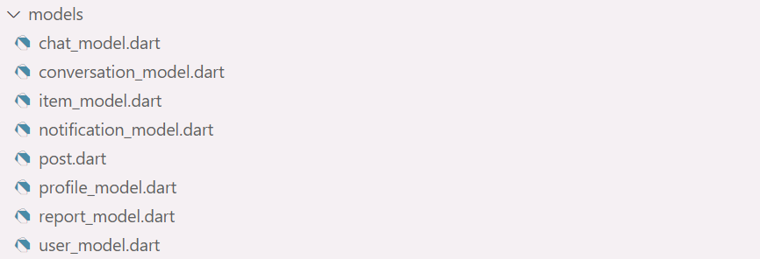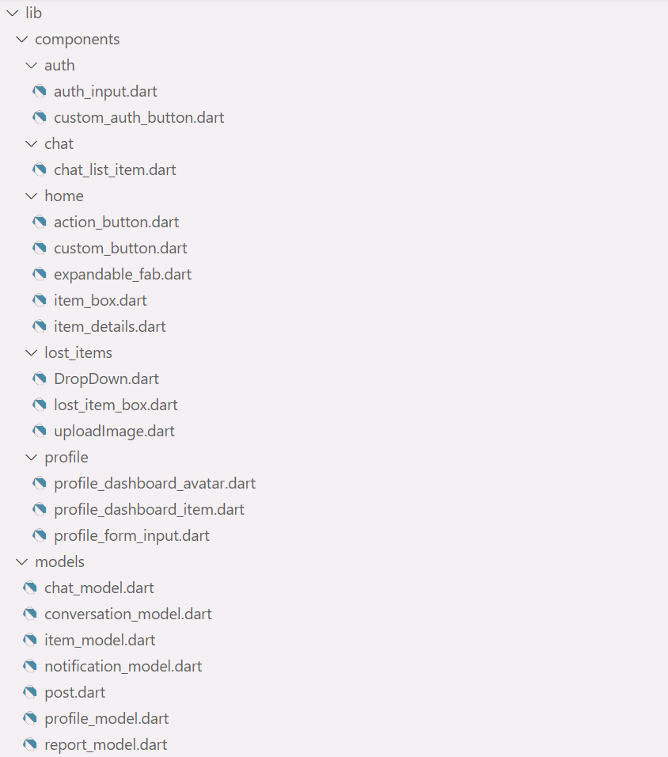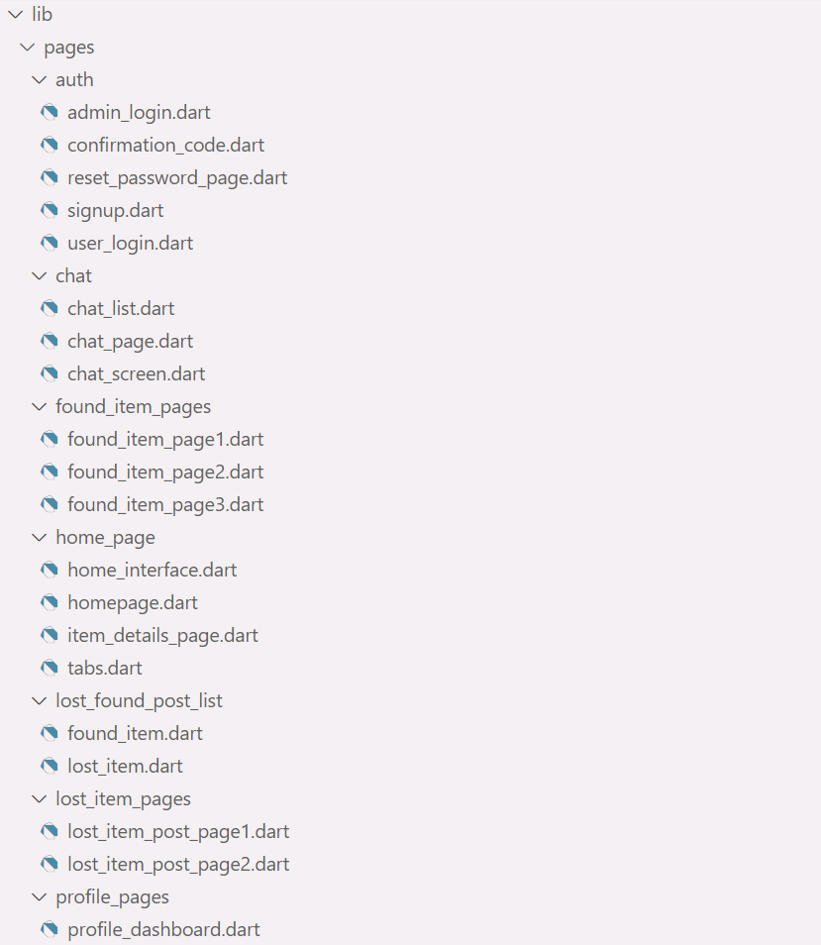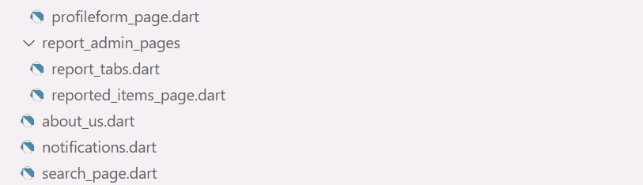

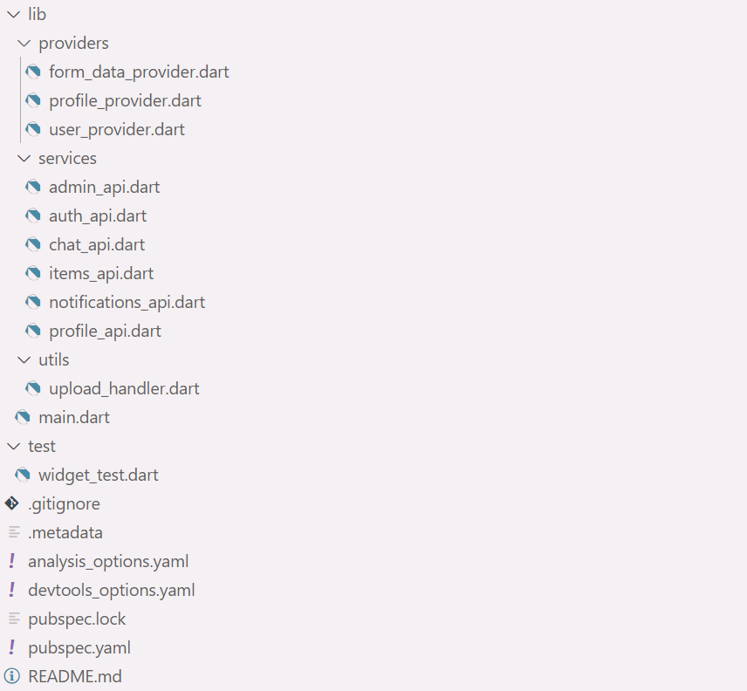

### Backend Directory

The backend contains a .env file containing environment variables such as API keys in the root directory. Flask code is placed under the folder titled lostify; however, the code must be run from the root directory itself.

### Databases

#### awaitOTP

|  |  |  |  |
| --- | --- | --- | --- |
| **Field Name** | **Type** | **Constraint** | **Function** |
| username | Text | Primary Key Not Null | Email address of user |
| password | Text | Not Null | Password |
| otp | Integer | Not Null | Otp |
| created | Integer | Not Null | Time of OTP generation |
| profile | Text | Not Null | Profile Details |

#### users

|  |  |  |  |
| --- | --- | --- | --- |
| **Field Name** | **Type** | **Constraint** | **Function** |
| id | Integer | Primary Key Autoincrement | Email address of user |
| username | Text | Unique Not Null | Name |
| password | Text | Not Null | Password |
| role | Integer | Not Null | 0 for students 1 for admin |
| counter | Integer | Not Null Default 0 | Number of failed login attempts |
| lastAttempt | Integer | Not Null | Time of last unsuccessful attempt |

#### profiles

|  |  |  |  |
| --- | --- | --- | --- |
| **Field Name** | **Type** | **Constraint** | **Function** |
| userid | Integer | Primary Key Not Null  Foreign Key: users(id) |  |
| name | Text | Not Null | Name of the user |
| phone | Text |  | Phone number |
| email | Text |  | Email address |
| address | Text |  | Residence address |
| designation | Text |  | Designation |
| roll | Integer | Unique Not Null | Roll number |
| image | BLOB |  | Profile image |

#### posts

|  |  |  |  |
| --- | --- | --- | --- |
| **Field Name** | **Type** | **Constraint** | **Function** |
| id | Integer | Primary Key Autoincrement | Email address of user |
| type | Integer | Not Null | 0 for lost  1 for found |
| creator | Integer | Not Null | User id of the post creator |
| title | Text | Not Null | Post title |
| description | Text |  | Post description |
| location1 | Text | Not Null | Coarse location of find/loss |
| location2 | Text |  | Fine location of find/loss |
| image | BLOB | Image | Image of article |
| date | Integer | Not Null | Date of post creation |
| closedBy | Integer | Not Null | User id of claimant |
| closedDate | Integer | Not Null | Date of closing post |
| reportCount | Integer | Not Null Default 0 | Count of reports |

#### reports

|  |  |  |  |
| --- | --- | --- | --- |
| **Field Name** | **Type** | **Constraint** | **Function** |
| postid | Integer | Not Null | Post id of reported post |
| userid | Integer | Not Null | User id of reporter |

#### confirmations

|  |  |  |  |
| --- | --- | --- | --- |
| **Field Name** | **Type** | **Constraint** | **Function** |
| postid | Integer | Not Null | Post id |
| Initid | Integer | Not Null | Id of initiator |
| otherid | Integer | Not Null | Id of user from whom confirmation is pending |

### Setting up the Development Environment

#### Frontend

1. Clone the repository from GitHub.
2. Navigate to the frontend directory and open it in Android Studio.
3. Run flutter pub get to get the updated dependencies.

#### Backend

1. Clone the repository from GitHub.
2. Navigate to the backend directory and create a virtual environment.
3. Activate the environment in the terminal.
4. Install the dependencies specified in the requirements.txt file using pip install -r requirements.txt.
5. Create a .env file with the database path and API keys.
6. Start the development server with flask –app lostify run.

# Completeness

## Implemented Features

### Home Interface

When the app starts, the home screen appears with three options:

* **User Login** – Takes users to the login page.
* **Admin Login** – Directs administrators to the admin login page.
* **Not a member? Register now** – Guides new users through the registration process.

### Login

Login requires an email address and password for authentication.

The login page includes a ‘Forgot Password’ button, which redirects users to the password reset flow.

Upon successful login, users are redirectedto the homepage**.**

### Password Reset

Users initiate the password reset process by entering their registered email address, which redirects to the confirmation code page.

* An OTP (One-Time Password) is sent to the given email for verification.
* The confirmation code page provides an option to resend the OTP if necessary.
* Upon successful verification, users can set a new password, after which they are redirected to the home page.

### Registration

* Clicking ‘Not a member? Register now’ redirects to the Sign-up Page, where users provide:
  + Email Address
  + Password
* On the next page, users proceed to the Create Profile Page, where they enter:
  + Display Name
  + Phone Number
  + Campus Address
  + Designation
  + Roll Number
  + Profile Image
* Upon submitting profile details, users are redirected to the page for OTP verification.
* After successful verification, users are redirected to the home page.

### Homepage and Dashboard

The home page contains the following elements:

* A floating action button that expands into two floating action buttons when tapped:
  + Post a Lost Item.
  + Post a Found Item.
* Tabs:
  + **Lost** – Displays only lost item chats.
  + **Found** – Displays only found item chats.
* Hamburger icon: Opens a dashboard to navigate to other parts of the app*.*
* Search icon: Opens the search page.

### Posting Lost and Found Items

Opens a form where the user provides:

* A title for the post
* Description of the article
* Image of the article
* Location where the item was lost/Location where the item found can be collected
* Date and time of the loss/find

### Own Posts

The user can view his/her own posts and manage them from two sections:

* **Your Lost Items** – Shows all chats related to the user's lost items.
* **Your Found Items** – Displays all chats related to the user's found items.

This page is reached from the dashboard.

### Messages

The messages page is a centralised view of the user’s chats with other users regarding posts. This page can be reached from the dashboard.

### Search

The user can search for a post through the search facility provided.

* The user navigates to the search page from the homepage by tapping the search icon on the app bar.
* The user uses the following fields to refine their search:
  + Location
  + Date range

### View Reported Items

Users have the facility to flag posts. Admins can view a list of reported posts sorted in descending order of count of users who reported them. They may also delete posts from this page.

This page can be navigated to from the dashboard; the relevant option appears only for admins.

### Edit Profile

The user can edit his/her profile at any time.

* From the dashboard, the user opens the Edit Profile page.
* The user may edit any of the following details:
  + Display Name
  + Phone Number
  + Campus Address
  + Designation
  + Roll Number
  + Profile Image
* The user may then submit the form, whereupon his/her profile is updated with the new details.

### Logout

The user can log out from the dashboard; he/she is then redirected to the home interface.

## Future Development Plans

### Google Maps API integration

* **Live Item Location Pinning** – Users can mark the last known location of lost items.
* **Real-Time Directions to Found Items** – Guide users to lost items reported nearby.

### Community engagement and partnerships

* **Extend to other institutions** – The application can be customised for use by other educational institutions, offices and similar establishments.
* **Gamification and Rewards** – Introduce points or incentives for users who report found items.

### AI-powered image and text recognition

* **Image Matching** – AI-based image recognition to match found items with lost reports automatically.
* **OCR (Optical Character Recognition)** – Extract details from images of receipts, tags, or engravings on objects.
* **Categorisation** – Autogenerate descriptions for items from their images.

### Priority Recognition

* **Urgency Detection** – Items like passports or wallets can be prioritised and displayed higher up in the homepage and search results.

### Porting to iOS

* **Future Expansion to iOS** – Lostify is Android-only now, but Flutter allows easy transition to iOS.
* **Uniform UI/UX Across Platforms** – Ensure consistency in design and features.
* **Apple Maps Alternative for iOS** – Option to switch between Google Maps and Apple Maps.

1. Group Log

|  |  |  |
| --- | --- | --- |
| Date & Time | Venue | Minutes |
| 07/03/25  11:00 pm | 4th floor, Rajeev Motwani Building | Discussed implementation iork, decided the work and team meet timelines, and distributed work among teammates.  Decided the tentative dates for completion of frontend and backend components, as well as the start date for integration of both ends. |
| 09/03/25 3:00 pm | Online | Gathered resources for learning Flask and Flutter and set up our machines for the development process.  Redesigned the logo for the app.  Basic layout of the app refined for development. |
| 13/03/25  9:00 pm | Online | Revision of components and distribution of individual pages of the application. |
| 17/03/25 9:00 am | 1st floor, Rajeev Motwani Building | Met to compile our work and analyse our progress and plan future development processes.  Discussed more about the Flask backend routes and decide the app's routes. |
| 19/03/25  10:00 pm | 1st floor, Rajeev Motwani Building | Further progress on frontend/learning routes and other backend-related knowledge.  Learned more about the APIs necessary to facilitate backend.  Revised plans and timelines for backend implementation. |
| 22/03/25  9:00 pm | 1st floor, Rajeev Motwani Building | Finished the frontend. Began working on the backend and integration.  Started working on the implementation document. Distributed the backend work amongst teammates. |
| 26/03/25  10:00 am | 1st floor, Rajeev Motwani Building | Completed backend and frontend. Started working on the integration process.  Finalized the design for the databases needed for the code. |
| 27/03/25  6:00 pm | 1st floor, Rajeev Motwani Building | Further discussion on integrating frontend/backend.  Work on user manual started.  Work on testing document started. |
| 28/03/25  2:00 pm | 1st floor, Rajeev Motwani Building | Finalized the Implementation Document.  Successfully established important routes of the app.  Made progress in integration and uploaded the necessary files on GitHub. |